Grant Grummer

2/11/2021

Dazzelite Installation & Setup

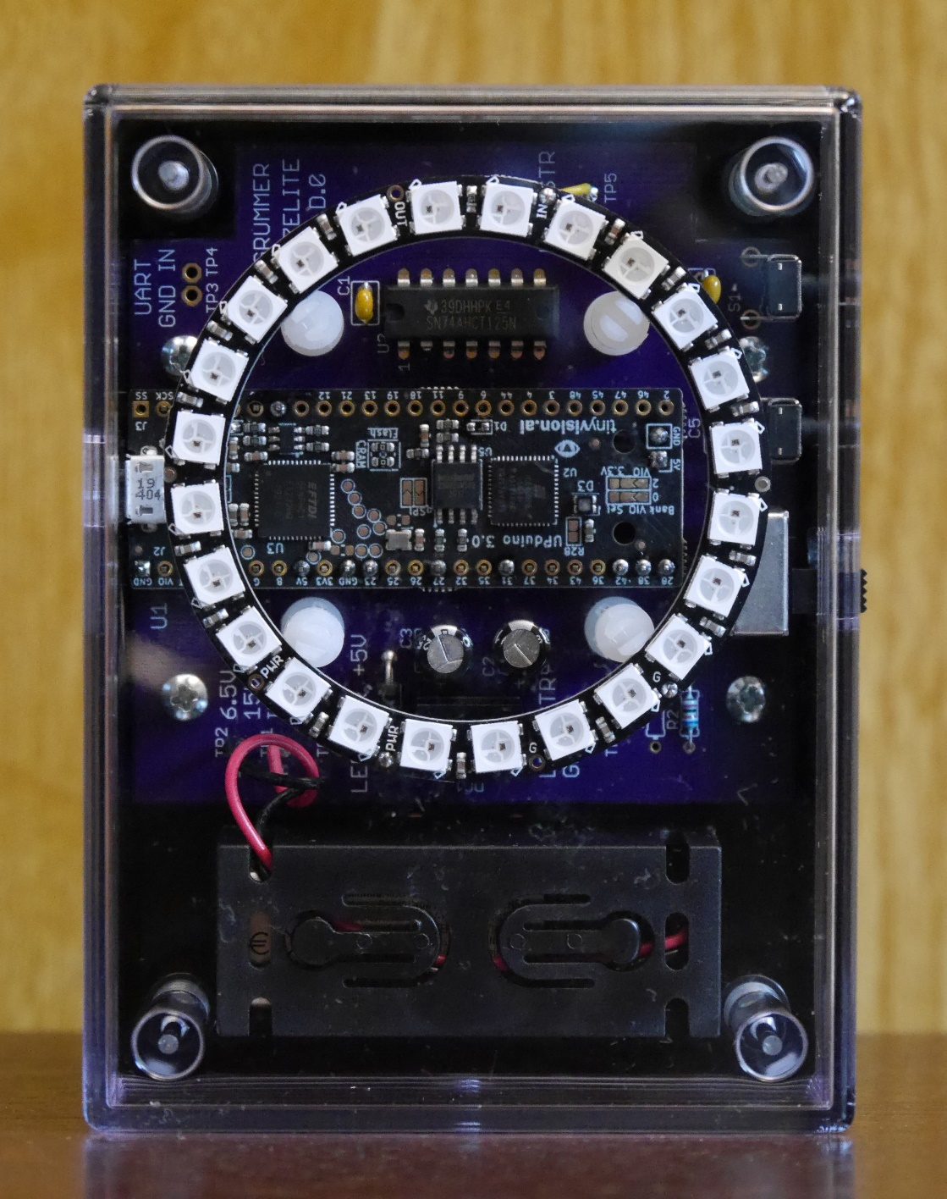

Revision: A.0

Table of Contents

Introduction 1

Installing Build Tools 1

Download Dazzelite Files 1

Building the Design for the First Time 1

# Introduction

Welcome to the Dazzelite project setup. Whether you’re planning to build a version on a breadboard, a perfboard or a custom PCB, the follow information will help you on your way. This document covers Windows installations only.

# Installing Build Tools

The design was built using the Lattice Semiconductor Radiant platform. There are other tools one could use, but that would require significant changes to the supplied code. Radiant is free and is available on the Lattice website at:

[http://www.latticesemi.com/Products/DesignSoftwareAndIP/FPGAandLDS/Radiant](http://www.latticesemi.com/Products/DesignSoftwareAndIP/FPGAandLDS/Radiant%20)

You’ll find useful documentation on that web page. The Radiant Software Installation Guide document has important installation and license information. A license is required to run Radiant. The link to obtaining a license is also at the above website. Follow the license link. You’ll be asked to sign in to your account. If you don’t have one, you’ll need to create by selecting the “Create Account” link.

Once a license is obtained, download and install Radiant. When the “Select Component(s)” window opens, the only FPGA device you’ll need is the “Lattice iCE40UP”, though it’s ok to install more devices if desired.

# Download Dazzelite Files

The Dazzelite files are located in GitHub. In order to download the files, one clones the directories using “[GitHub Desktop](https://desktop.github.com/)”. Once GitHub Desktop is installed, the Dazzelite project is located at:

<https://github.com/ggrummer/Dazzelite>

Place all the files and directories in a new directory. The design was built using the following root directory structure: “C:\Projects\Dazzelite”. It may be OK to use a different directory structure, but that hasn’t been tested.

# Building the Design for the First Time

Start the Radiant program. Double click on the “Open Project” icon. See Figure 1.

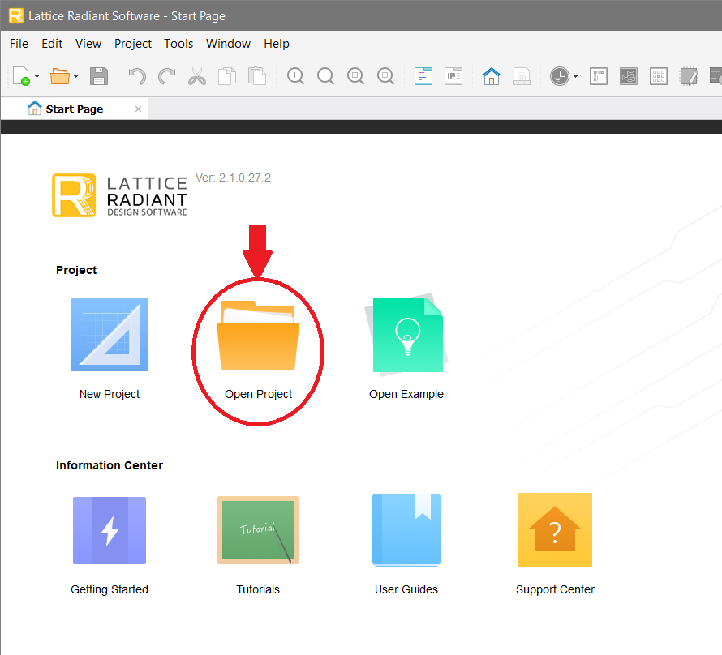

Figure 1: Open Project Window

Navigate to the “Dazz12” directory and select the “Dazz12.rdf” file. The Lattice Radiant Software main window will open. Click on the “Run All” triangle. See Figure 2.

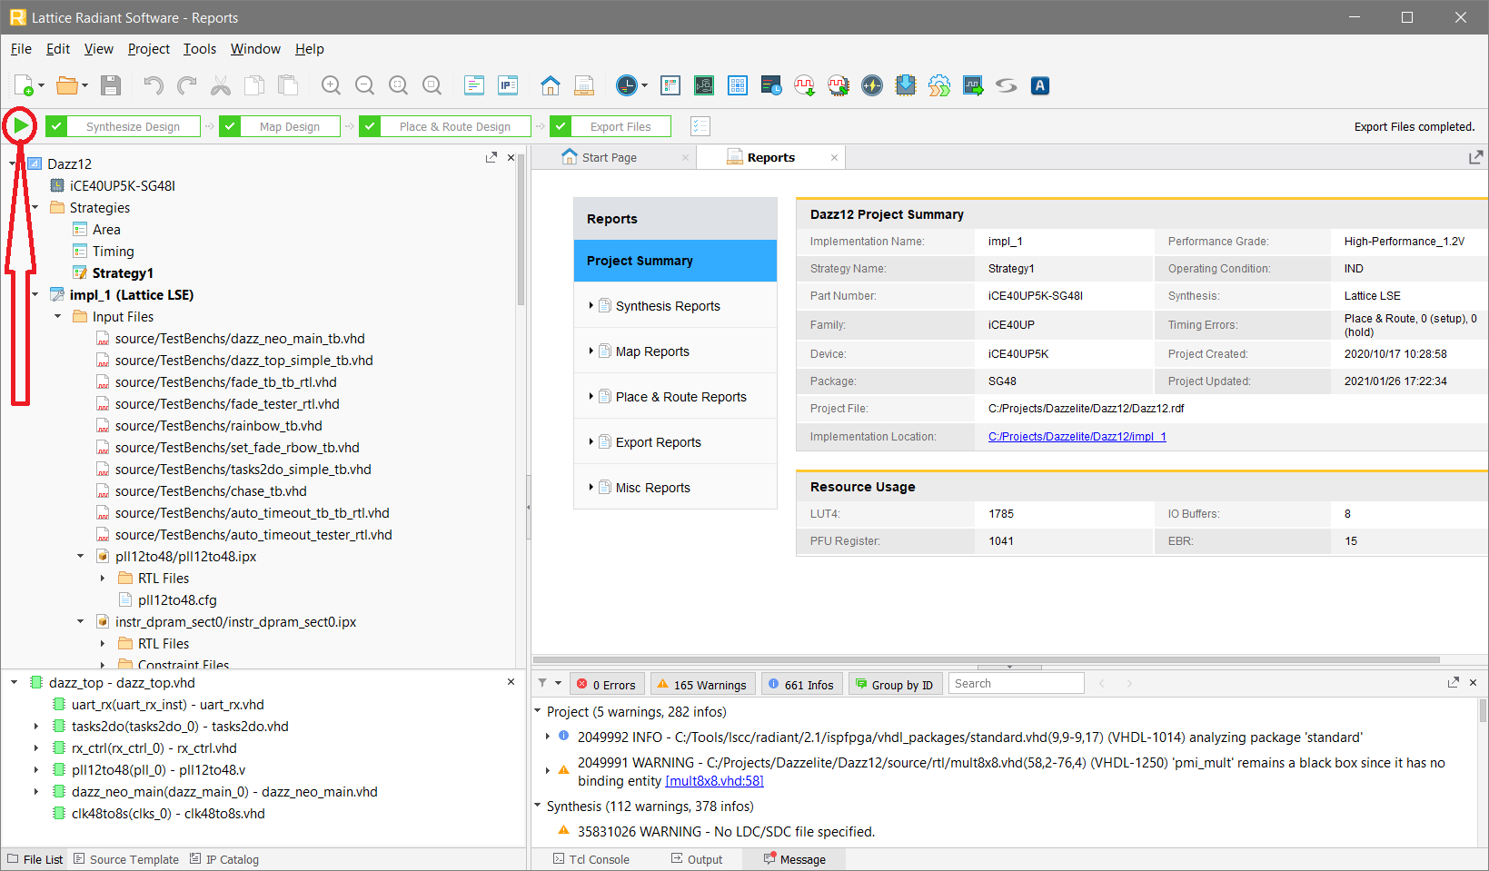

Figure 2: Lattice Radiant Software Window

The boxes to the right of the “Run All” triangle all turn green (with a check mark) once the design has been built.